1. Read data from s_HREMPLOYEES table and load the data in newly created table in SQL server database

Dataflow for data loading

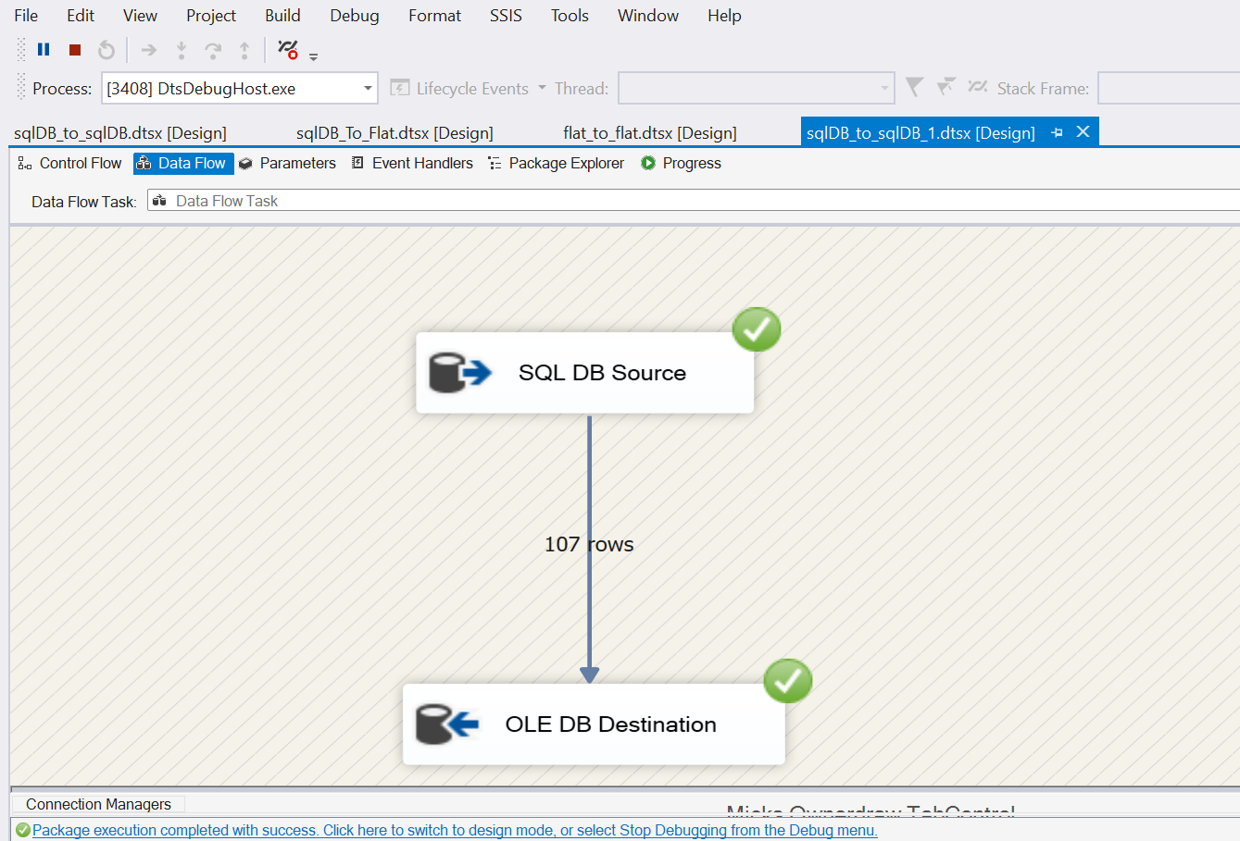

Destination SQL query with loaded data

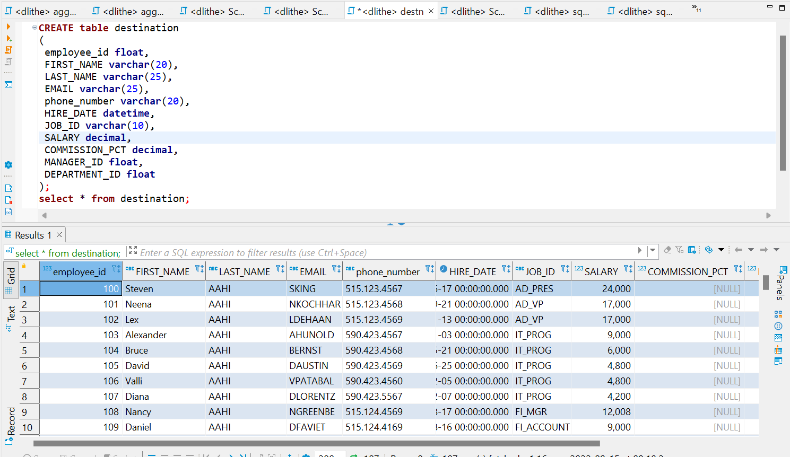

1. Read the data from s_HREMPLOYEES table and load the data in flat file

Dataflow for data loading

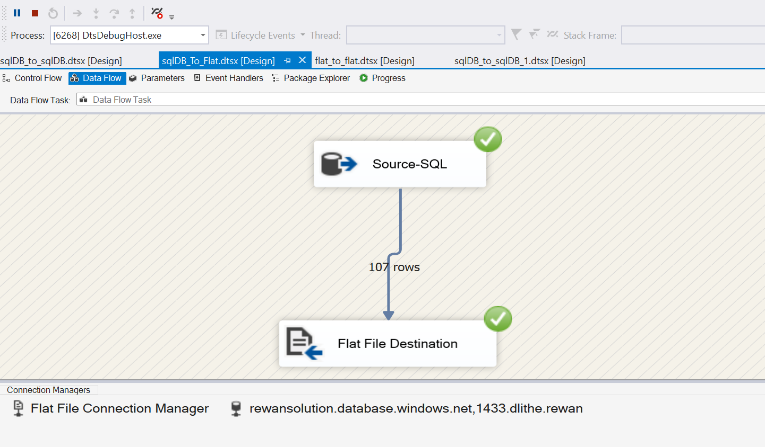

Destination flat file of loaded data

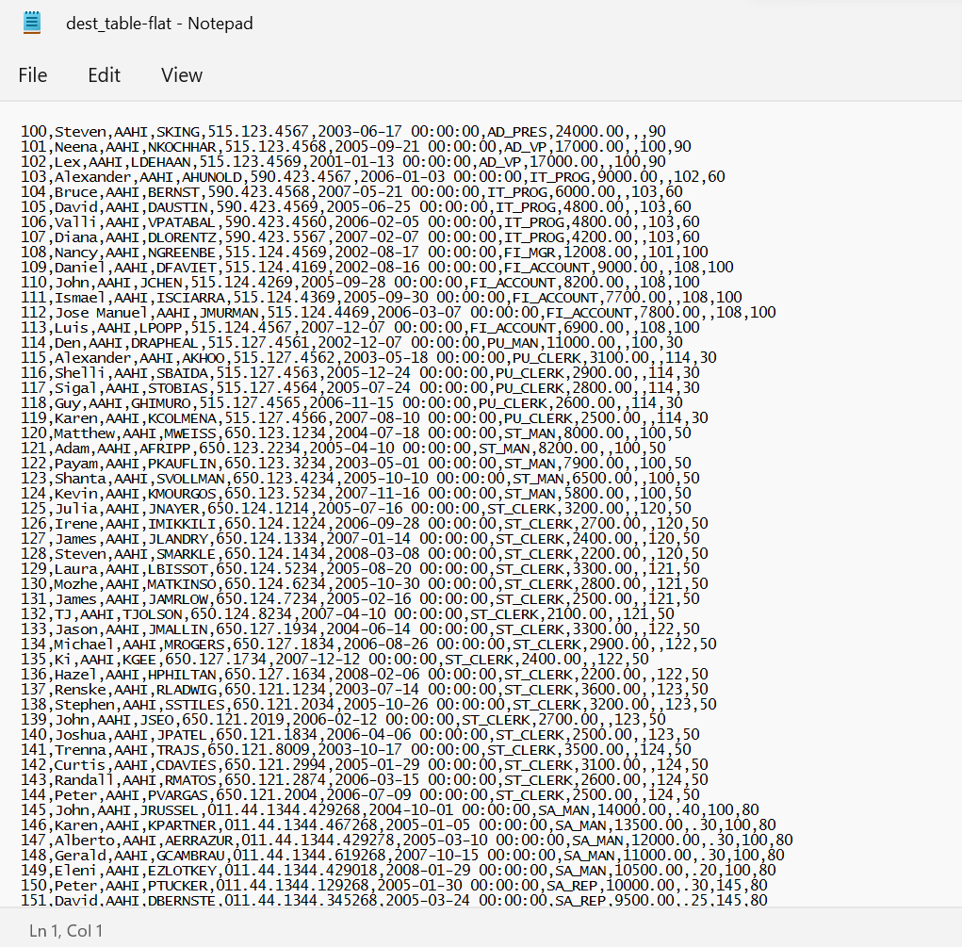

1. Read the data from flat file and load the data in newly created table in sql server

Dataflow for data loading :

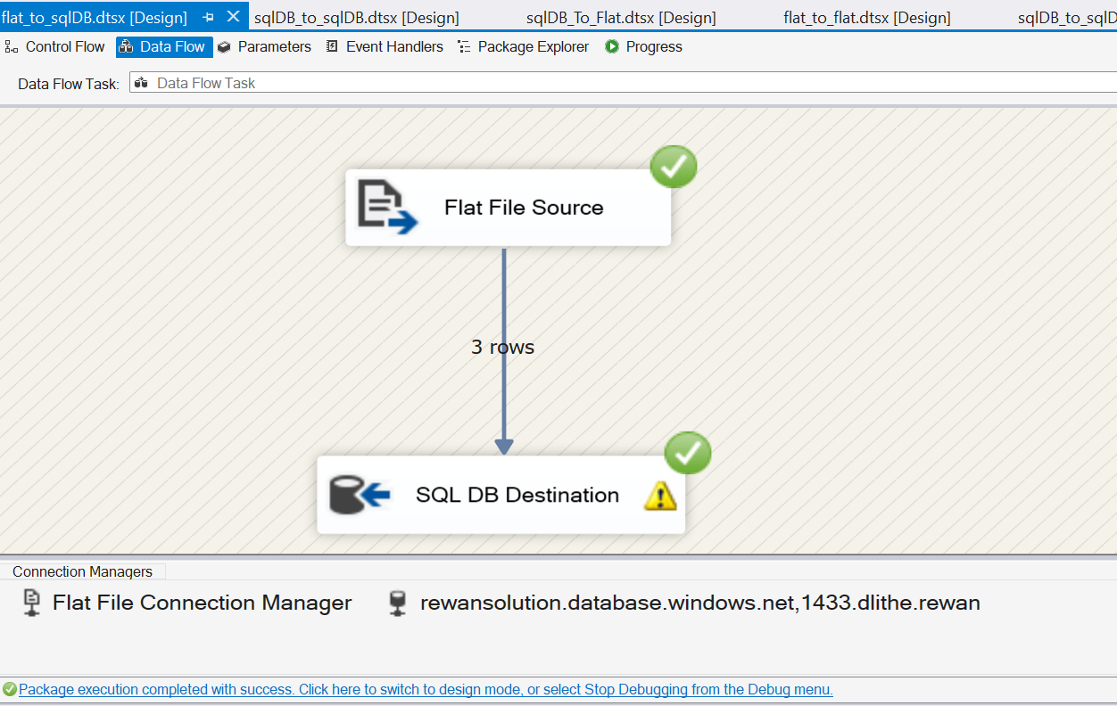

Source flat file

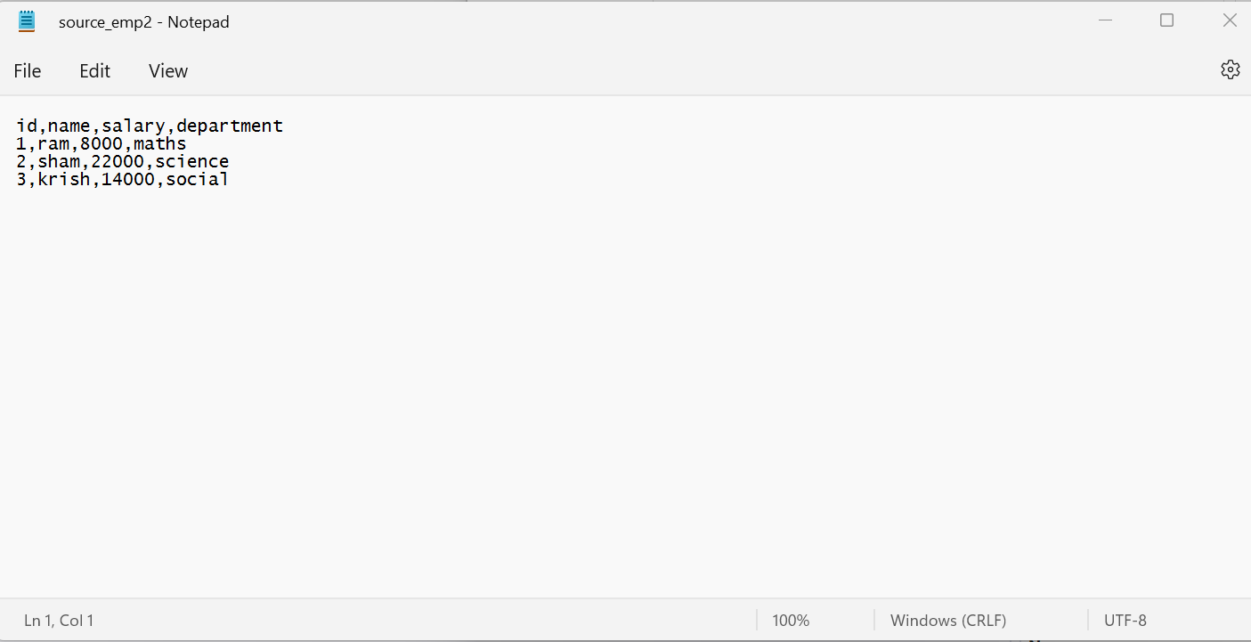

Destination sql query with loaded data

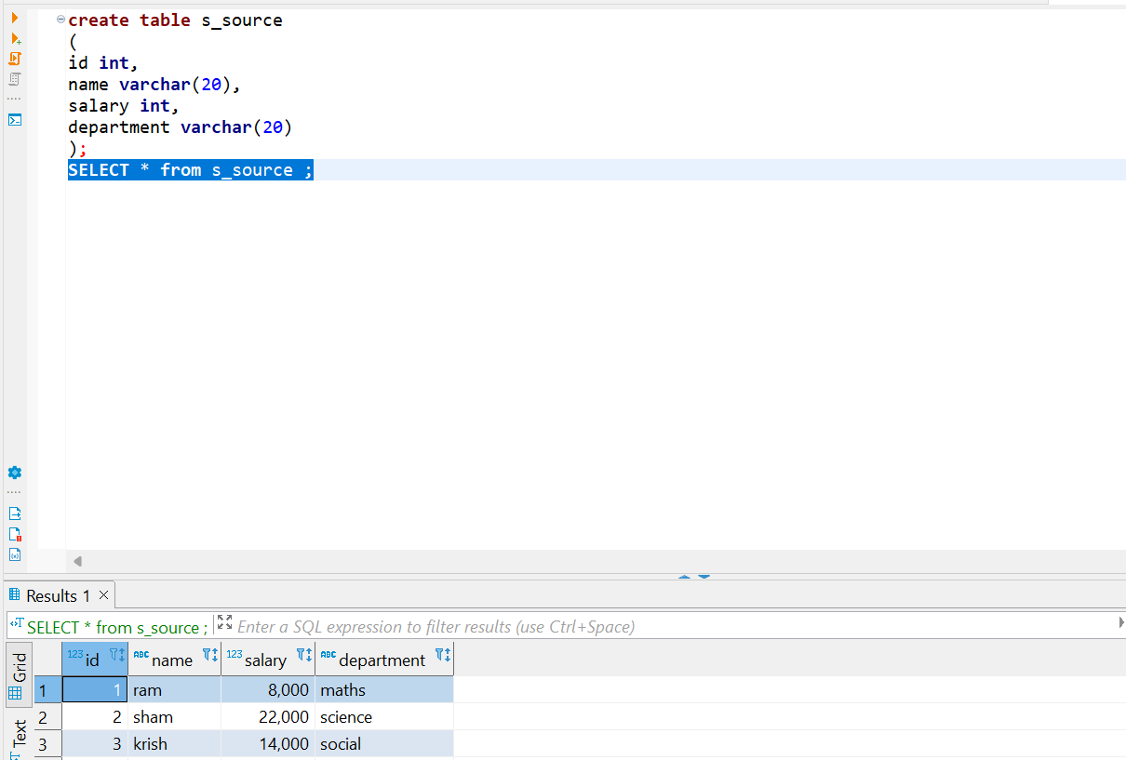

1. Read the data from flat file and load the data in flat file

Dataflow for loading the data

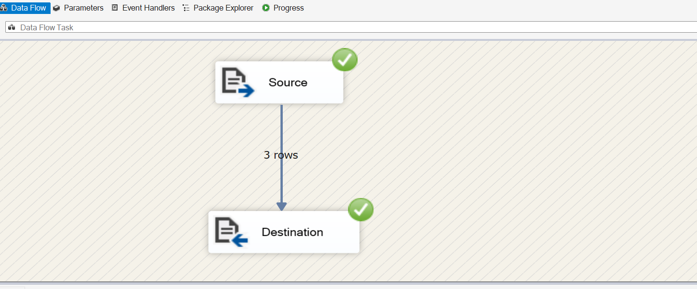

Flat file source

Flat file destination

